Go to B+Tree in Javascript Page
Links to an external site., build a B+ tree of order 4 and insert at least 20 random values into the tree. Take a screenshot.
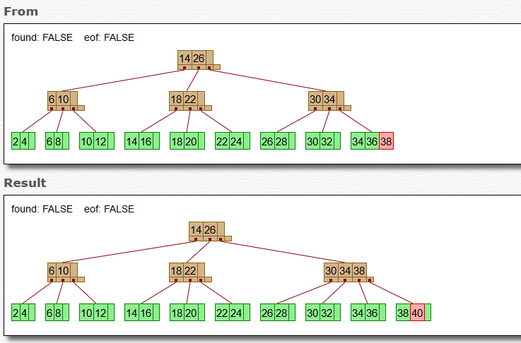
Keep inserting values until a leaf node in the tree splits. Take a screenshot of the tree and explain why the node splits.
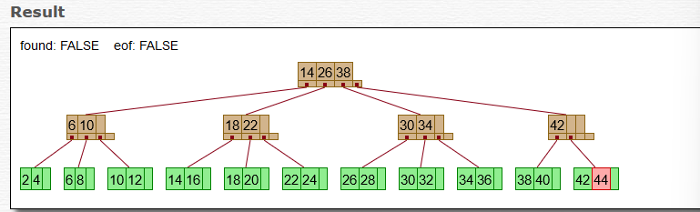
- The node splits because it has reached its maximum becoming full resulting in the node splitting making it necessary to maintain all the B+ Tree properties.
Keep inserting values until the tree’s height increases. Take a screenshot and explain why the height has increased.
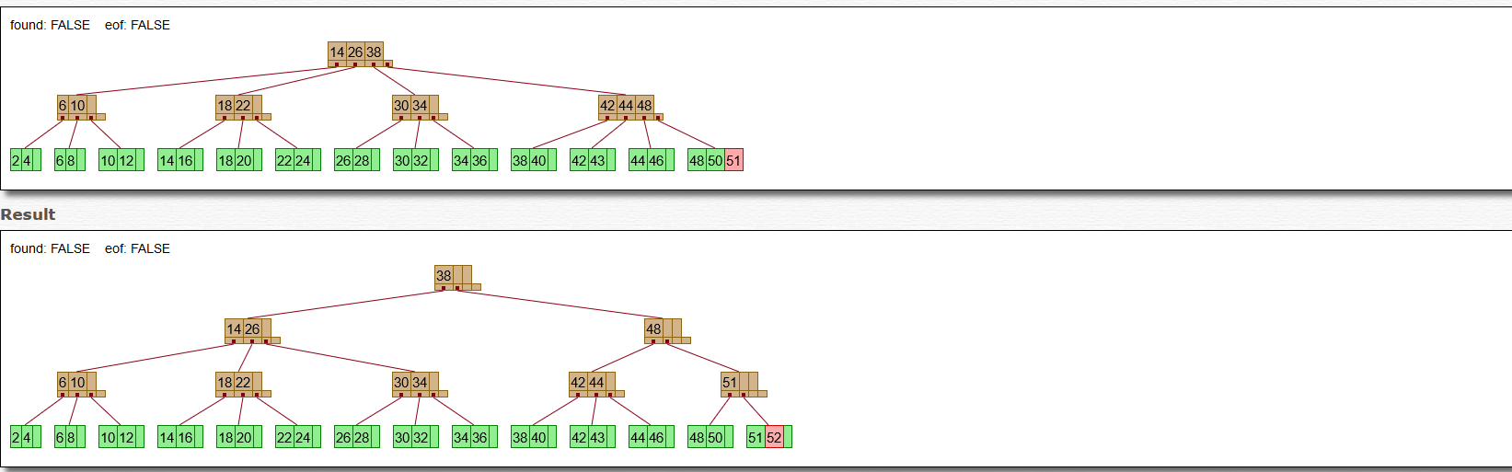
- The height has increased because when adding more values the nodes will eventually reach its maximum capacity when this happens it will result in a full node to split into two nodes. This is in order the preserve the structure of the B+tree and as a result the tree’s height will increase by one level
Keep deleting values until the tree’s height decreases. Take a screenshot and explain why the height has decreased.
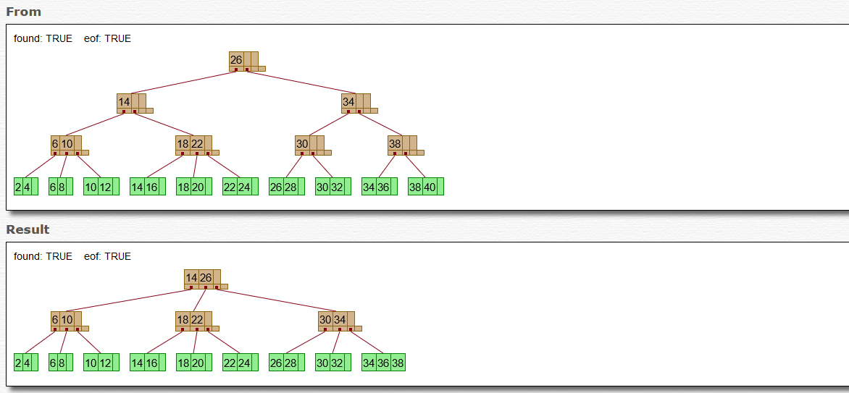
-The height has decreased because of the deletions that were performed this results in a node being underfull and also containing lesser keys than what is required in this case it may cause some nodes to merge to maintain the characteristics of the B tree resulting in the tree height to decrease. We can see this merge happen from the before and after screenshot in which several nodes have merged resulting in the decrease.

